**Project Design Phase-II**

**Technology Stack (Architecture & Stack)**

|  |  |  |  |
| --- | --- | --- | --- |
| Date | 24 June 2025 | | |
| Team ID |  | LTVIP2025TMID49911 |  |
|  |
| Project Name | Cosmetic Insights : Navigating Cosmetics Trends and Consumer Insights with Tableau | | |
| Maximum  Marks | 4 Marks | | |

**Technical Architecture:**

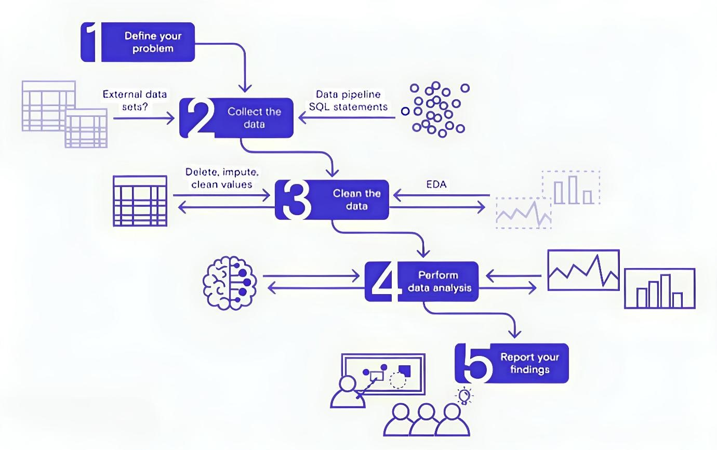

**Table-1 : Components & Technologies:**

|  |  |  |  |
| --- | --- | --- | --- |
| **S.No** | **Component** | **Description** | **Technology** |
| 1. | User Interface | Web interface for viewing dashboards and insights | HTML, CSS, JavaScript, Tableau  Public Embedding |
| 2. | Data Processing  Logic | Data cleaning & preprocessing scripts | Python (Pandas, NumPy) |
| 3. | Data Storage | Stores raw data and cleaned datasets | CSV files, Google Sheets, or simple  SQL/NoSQL DB (e.g., MySQL,  MongoDB) |
| 4. | Visualization Layer | Creates interactive visual dashboards and charts | Tableau Public / Tableau Desktop |
| 5. | Infrastructure  (Server / Hosting) | Hosts any scripts and serves embedded dashboards | Local Machine or Cloud VM (Render,  Railway, or simple shared hosting) |

**Table-2: Application Characteristics:**

|  |  |  |  |
| --- | --- | --- | --- |
| **S.No** | **Characteristics** | **Description** | **Technology** |
| 1. | Open-Source Frameworks | Uses open-source Python libraries for data processing | Python (Pandas,  NumPy) |
| 2. | Security | Secure storage and access to Tableau dashboards with controlled sharing | Tableau permissions, secure hosting |
| 3. | Scalable  Architecture | Justify the scalability of architecture (3 – tier, Micro-services) | Technology used |
| 4. | Availability | Dashboards accessible anytime via  Tableau Public or Cloud link | Tableau Public, Render,  Railway |
| 5. | Performance | Dashboards use Tableau Extracts for faster load; small datasets for demo | Tableau Data Extracts,  Python ETL |